Name: Class: Mark:

1. Dorset Hotels is a website that offers hotel accommodation.
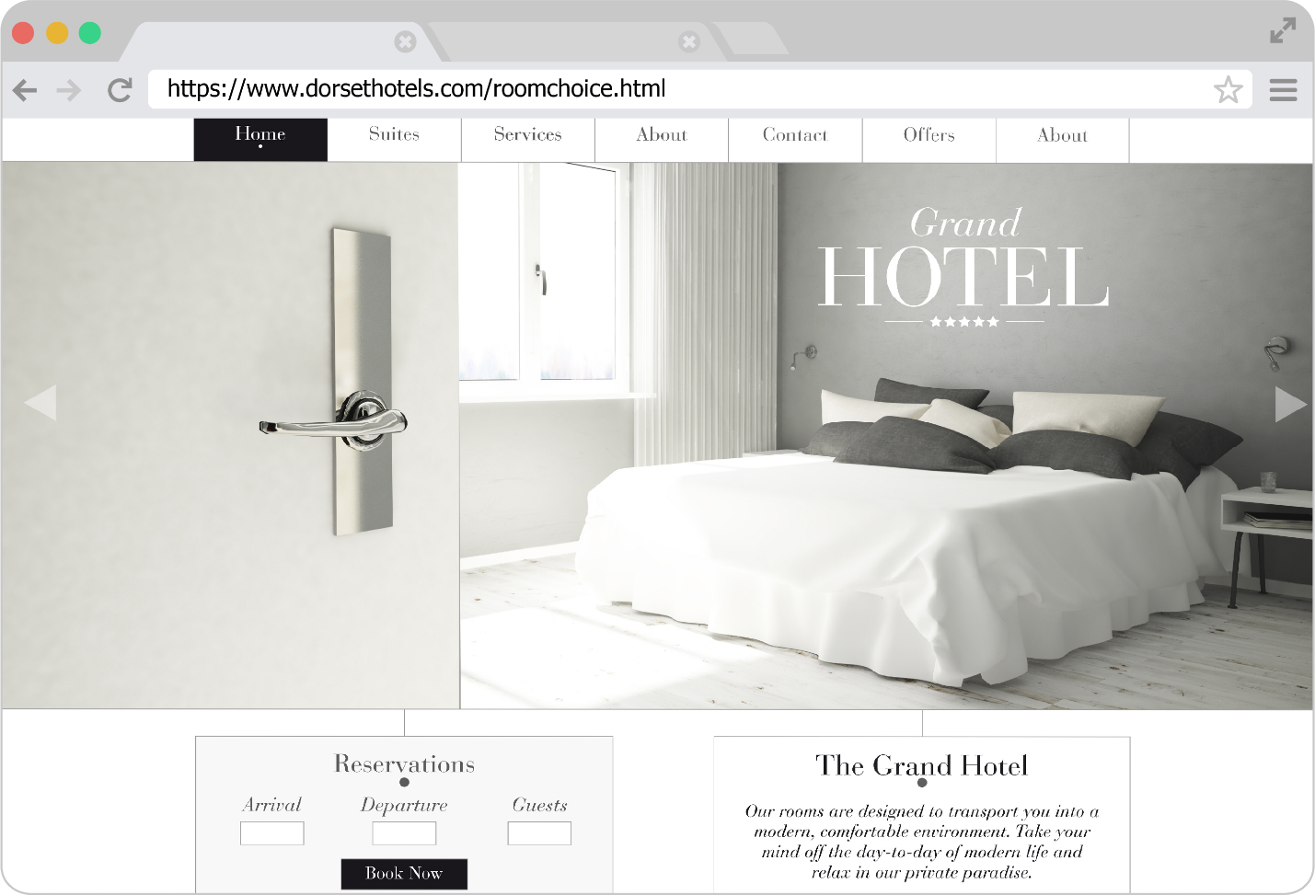
(a) The web page that is requested is located on the World Wide Web.
State the difference between the World Wide Web and the Internet. [1]

(b) State the domain name of the web page that has been requested. [1]

(c) Describe the purpose of HTTPS for this web page request. [2]

(d) The main purpose of a web browser is to render and display web pages. Web browsers also store cookies they receive. State three other functions of web browsers. [3]

(e) Dorset Hotels makes use of cookies. One reason for this is to remember users so that they don’t need to repeatedly login.
State one other reason that Dorset Hotels might use cookies. [1]

(f) When a user logs in, the website makes use of a persistent cookie. Explain one reason why the website developer has chosen a persistent cookie rather than a session cookie. [2]

(g) Dorset Hotels has started to accept a digital currency as payment for hotel rooms. Explain the purpose of a blockchain as part of these payments. [2]

(h) State the language that will be used to markup each webpage on the website. [1]

(i) Describe the role of DNS in retrieving the web page. [3]

2. Freddie has a new laptop which he connects to his home network to access the Internet.
(a) State the device that Freddie connects to. [1]

(b) Freddie’s laptop is allocated the number 192.168.1.7 when it connects to the home network.
State the type of address that is being used by his laptop. [1]

(c) Freddie’s internet service provider (ISP) allocates a static IP address to his house.
Explain what is meant by a static IP address. [2]

Freddie’s laptop states in the settings that it has the MAC address:
00:00:22:bc:ad:e2
(d) Explain the meaning of the term MAC address. [2]

(e) State the two components that make up a MAC address. [2]

(f) Give one role of a router in a network. [1]

(g) Freddie’s network currently makes use of IPv4.
Give two differences that IPv6 has compared to IPv4. [2]

3. Aruna works as a technician in a university’s IT services department.
Three possible threats to the network are:
- Brute-force attacks
- Distributed denial of service (DDoS) attacks
- Malware such as viruses and worms.
(a) State one other type of malware. [1]

(b) Researchers at the university can only enter their office by entering a four-digit number into a keypad at the door.
Describe how a brute-force attack could be used to gain access to an office. [2]

(c) A number of people at the university have contacted Aruna to say that the network has significantly slowed down. Aruna has found that the cause of the problem is that the university is experiencing a distributed denial of service (DDoS) attack.
Describe the processes involved in a DDoS attack. [3]

(d) The university makes use of a proxy server. Explain the purpose of a proxy server. [2]

(e) The university also makes use of access levels to improve the security of their system. Explain the restrictions that a researcher at the university is likely to experience on their files and computer services as a result of access levels.
Restrictions on files: [2]

Restrictions on computer services: [2]

(f) Give one other method that the university is likely to use to keep data safe from
security threats. [1]

[Total 40 Marks]

